Aberfoyle GO

Assigned to: Tyler

Reporting Month: March 2025

# Results and Discussion

# Appendix A: SGS Tables & Graphs

## Sewage Table

|  |  |  |  |  |  |  |
| --- | --- | --- | --- | --- | --- | --- |
| Date | BOD5 | TSS | TKN | TAN | NO3 | NO2 |
| 15-Jan-25 | 10 | 15 | 50.5 | 48.2 | 106 | 0.3 |

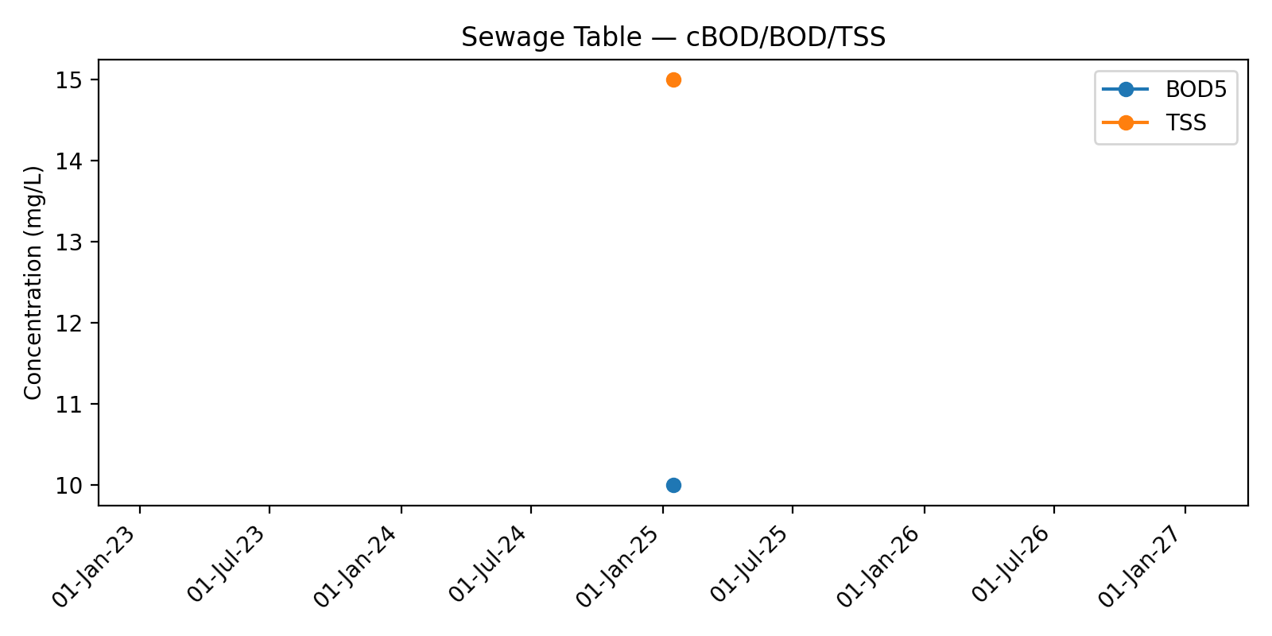

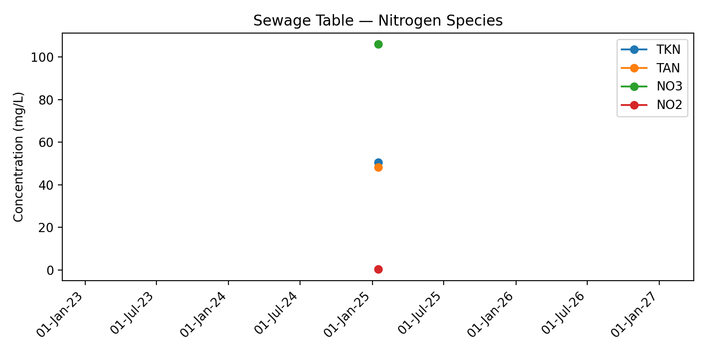

## Biofilter Effluent Table

|  |  |  |  |  |  |
| --- | --- | --- | --- | --- | --- |
| Date | cBOD5 | TSS | TAN | NO3 | NO2 |
| 15-Jan-25 | 10 | 4 | 32.8 | 120 | 0.3 |

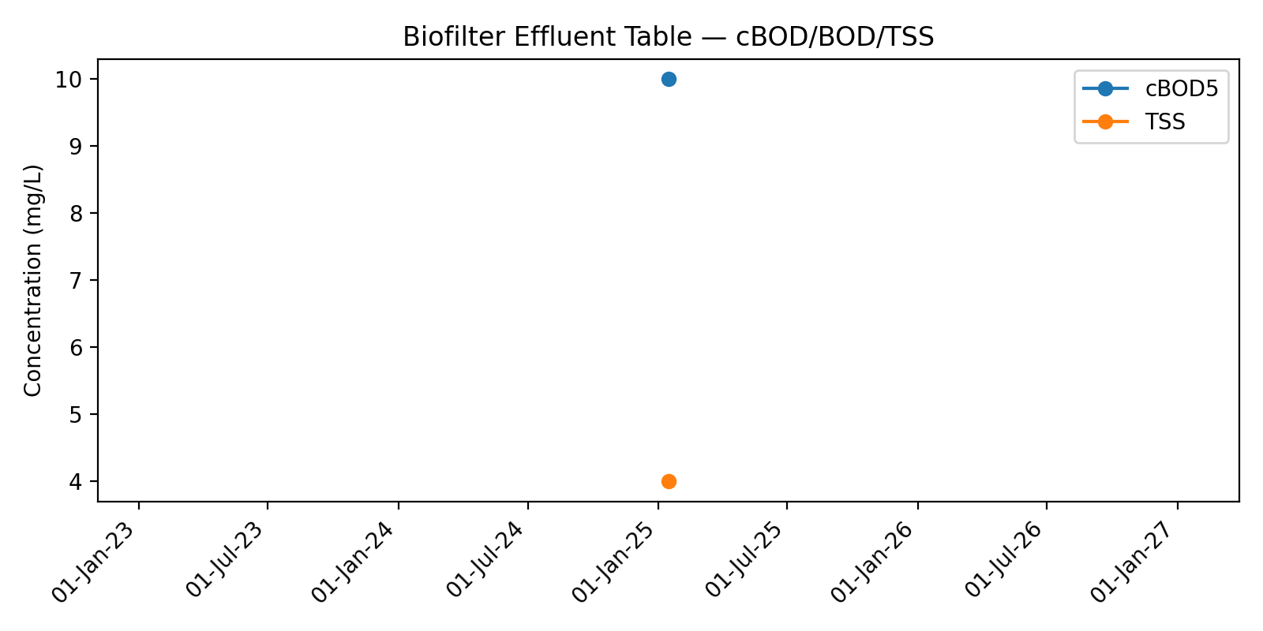

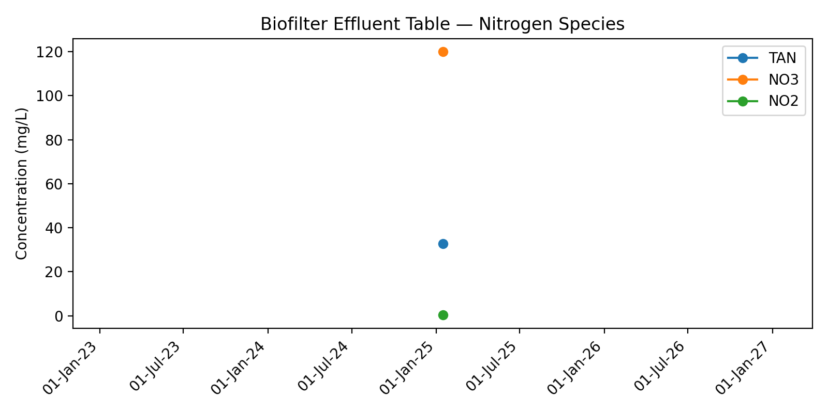

## WaterNOx-LS Effluent Table

|  |  |  |  |  |  |
| --- | --- | --- | --- | --- | --- |
| Date | cBOD5 | TSS | TAN | NO3 | NO2 |
| 15-Jan-25 | 11 | 5 | 36.2 | 0.6 | 0.3 |

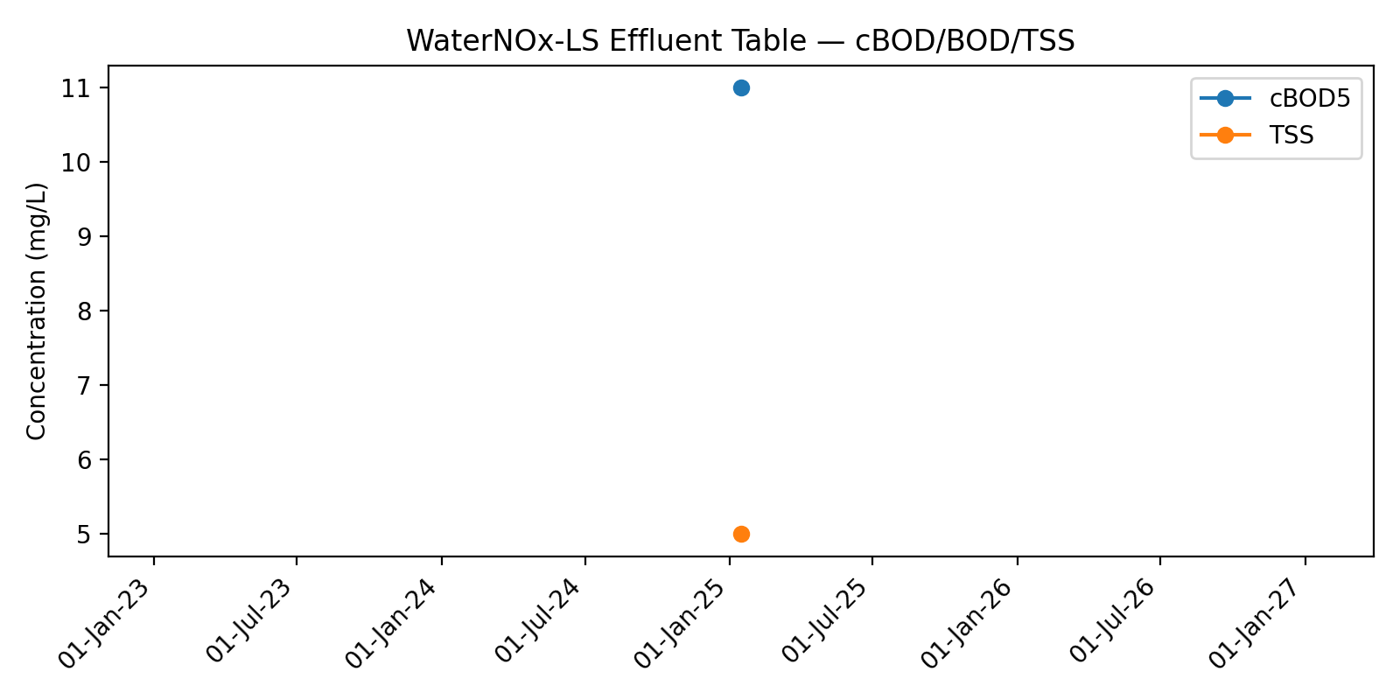

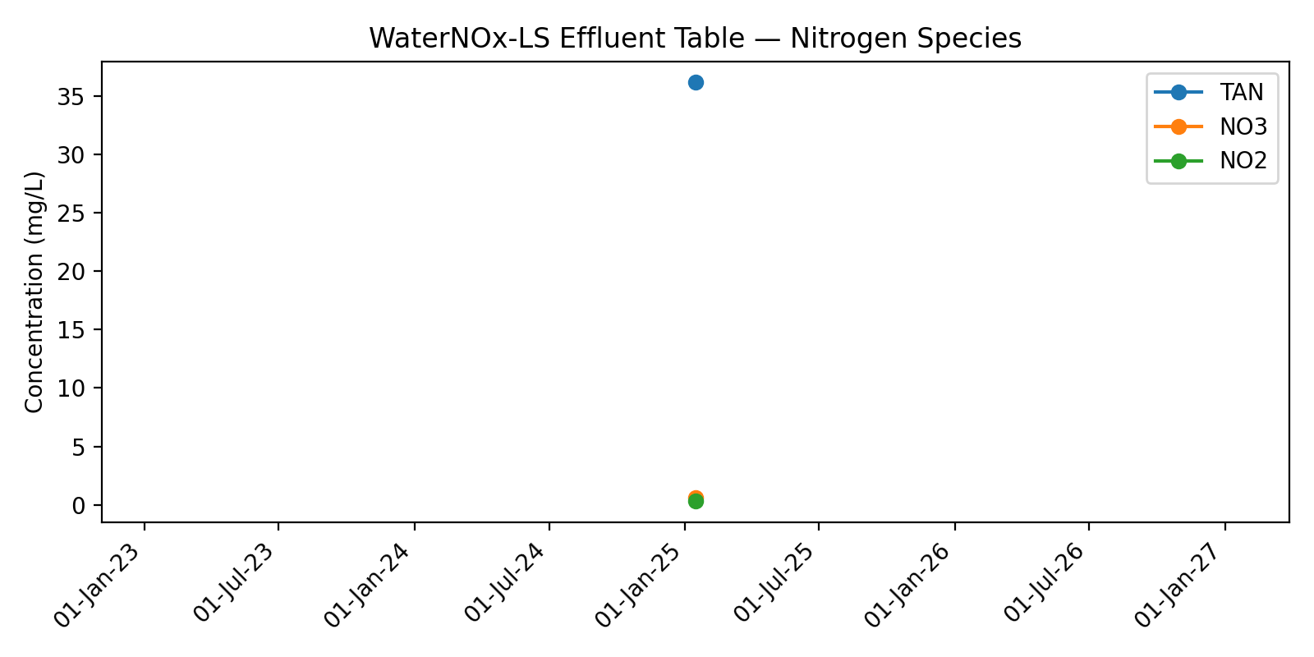

## Final Effluent Table

|  |  |  |  |  |  |
| --- | --- | --- | --- | --- | --- |
| Date | cBOD | TSS | TAN | NO3 | NO2 |
| 15-Jan-25 | 10 | 4 | 0.2 | 12.8 | 0.3 |
| 14-Feb-25 | 4 | 6 | 29.6 | 14.4 | 1.52 |
| 21-Mar-25 | 10 | 19 | 0.2 | 8.41 | 0.3 |

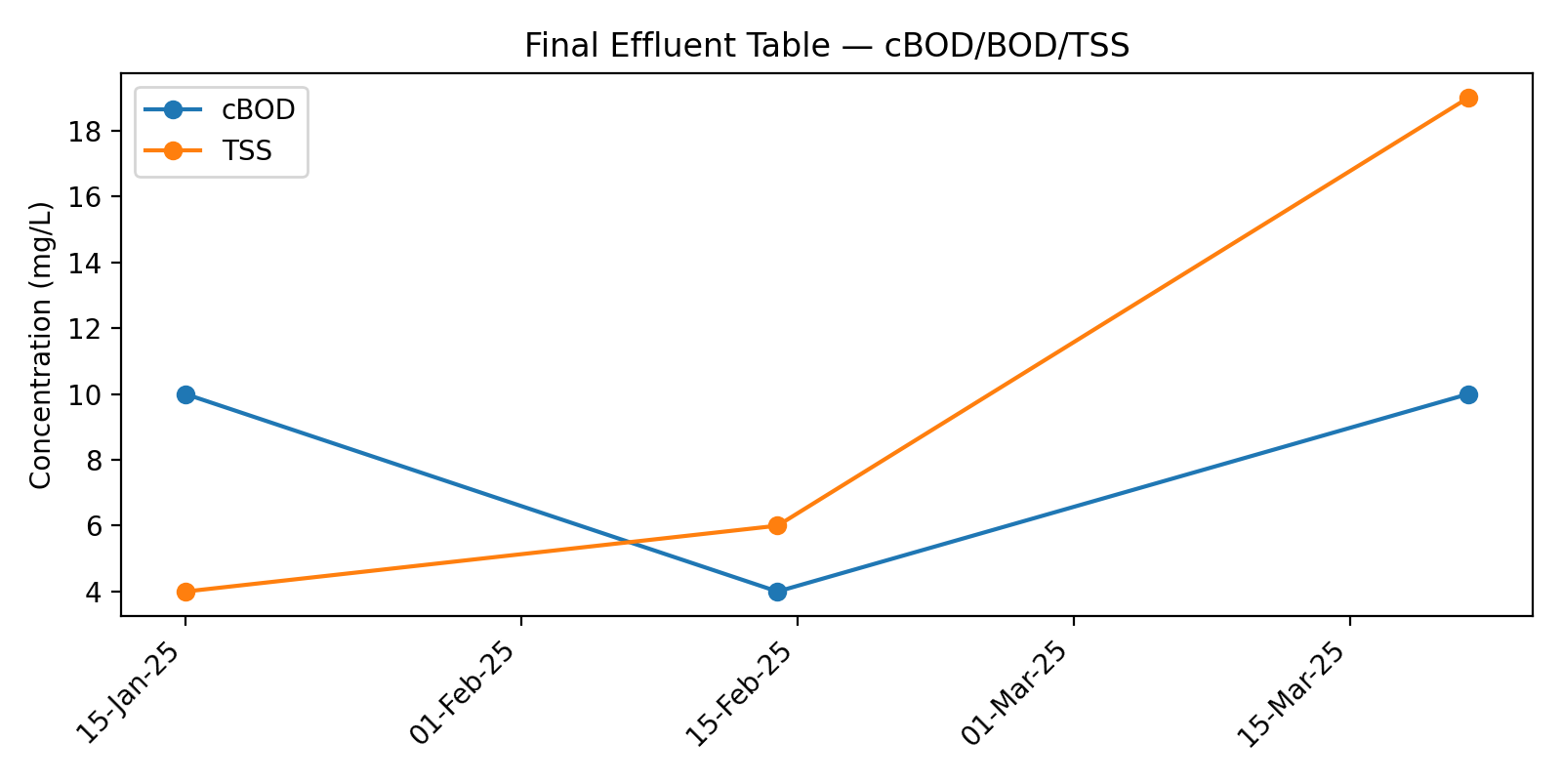

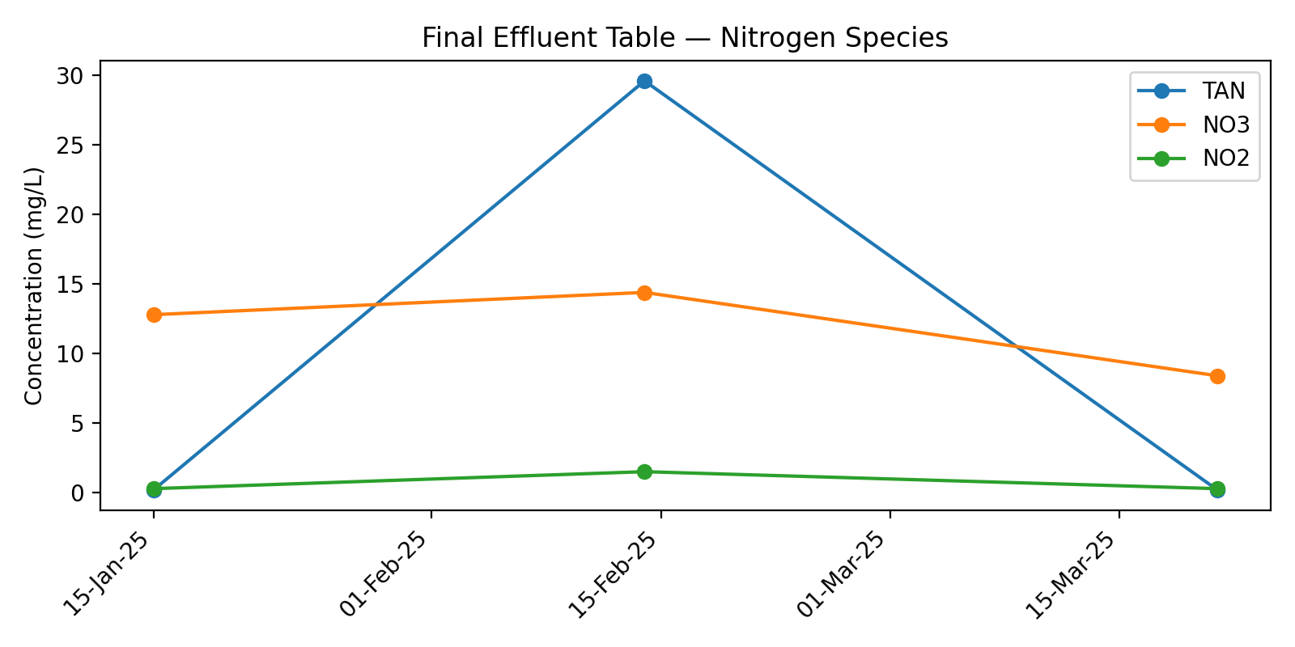

# Appendix B: Flow Data — January 2025

## Jan 25

|  |  |
| --- | --- |
| Date | Total Daily Flow (L/day) |
| 01-Jan-25 | 2525 |
| 02-Jan-25 | 0 |
| 03-Jan-25 | 0 |
| 04-Jan-25 | 0 |
| 05-Jan-25 | 3652 |
| 06-Jan-25 | 1225 |
| 07-Jan-25 | 2590 |
| 08-Jan-25 | 1292 |
| 09-Jan-25 | 1134 |
| 10-Jan-25 | 0 |
| 11-Jan-25 | 0 |
| 12-Jan-25 | 0 |
| 13-Jan-25 | 0 |
| 14-Jan-25 | 0 |
| 15-Jan-25 | 1302 |
| 16-Jan-25 | 0 |
| 17-Jan-25 | 0 |
| 18-Jan-25 | 0 |
| 19-Jan-25 | 1247 |
| 20-Jan-25 | 1246 |
| 21-Jan-25 | 0 |
| 22-Jan-25 | 0 |
| 23-Jan-25 | 0 |
| 24-Jan-25 | 0 |
| 25-Jan-25 | 4436 |
| 26-Jan-25 | 54 |
| 27-Jan-25 | 2525 |
| 28-Jan-25 | 0 |
| 29-Jan-25 | 1271 |
| 30-Jan-25 | 1281 |
| 31-Jan-25 | 2472 |
| Total Flow (L) | 28252 |
| Average Flow (L/day) | 911 |

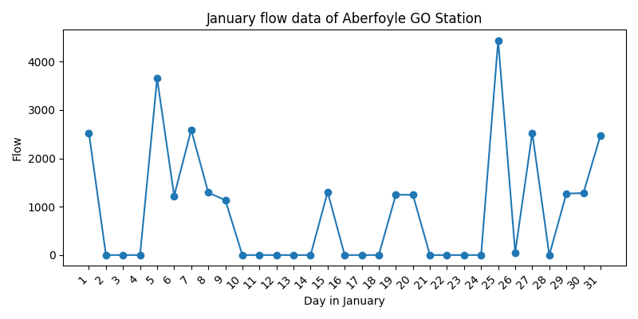

# Appendix C: Site Notes

# Appendix B: Flow Data — February 2025

## Feb 25

|  |  |  |  |  |
| --- | --- | --- | --- | --- |
| Date | Flowmeter (L/day) | Disposal 1 (L/day) | Disposal 2 (L/day) | Total Daily Flow (L/day) |
| 01-Feb-25 | 1238 | - | - | 1238 |
| 02-Feb-25 | 1212 | - | - | 1212 |
| 03-Feb-25 | 2330 | - | - | 2330 |
| 04-Feb-25 | 1286 | - | - | 1286 |
| 05-Feb-25 | 1310 | - | - | 1310 |
| 06-Feb-25 | 2465 | - | - | 2465 |
| 07-Feb-25 | 2411 | - | - | 2411 |
| 08-Feb-25 | 4706 | - | - | 4706 |
| 09-Feb-25 | 2423 | - | - | 2423 |
| 10-Feb-25 | 1212 | - | - | 1212 |
| 11-Feb-25 | 2251 | - | - | 2251 |
| 12-Feb-25 | 7118 | - | - | 7118 |
| 13-Feb-25 | 4747 | - | - | 4747 |
| 14-Feb-25 | 2432 | - | - | 2432 |
| 15-Feb-25 | 7453 | - | - | 7453 |
| 16-Feb-25 | 7043 | - | - | 7043 |
| 17-Feb-25 | 5623 | - | - | 5623 |
| 18-Feb-25 | 3174 | - | - | 3174 |
| 19-Feb-25 | 2422 | - | - | 2422 |
| 20-Feb-25 | 2554 | - | - | 2554 |
| 21-Feb-25 | 2387 | - | - | 2387 |
| 22-Feb-25 | 1190 | - | - | 1190 |
| 23-Feb-25 | - | 1127 | 0 | 1127 |
| 24-Feb-25 | - | 1105 | 1897 | 3002 |
| 25-Feb-25 | - | 1067 | 939 | 2006 |
| 26-Feb-25 | - | 2254 | 959 | 3213 |
| 27-Feb-25 | - | 3314 | 2812 | 6126 |
| 28-Feb-25 | - | 3331 | 3792 | 7123 |
| Total Flow (L) |  |  |  | 91584 |
| Average Flow (L/day) |  |  |  | 3271 |

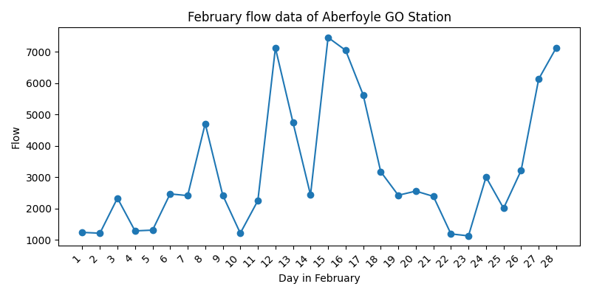

# Appendix C: Site Notes

# Appendix B: Flow Data — March 2025

## Mar 25

|  |  |  |  |
| --- | --- | --- | --- |
| Date | Disposal 1 (L/day) | Disposal 2 (L/day) | Total Daily Flow (L/day) |
| 01-Mar-25 | 3281 | 3108 | 6389 |
| 02-Mar-25 | 0 | 0 | 0 |
| 03-Mar-25 | 1089 | 947 | 2036 |
| 04-Mar-25 | 1187 | 941 | 2128 |
| 05-Mar-25 | 2325 | 1941 | 4266 |
| 06-Mar-25 | 4213 | 2915 | 7128 |
| 07-Mar-25 | 3244 | 3083 | 6327 |
| 08-Mar-25 | 2177 | 2049 | 4226 |
| 09-Mar-25 | 0 | 0 | 0 |
| 10-Mar-25 | 0 | 0 | 0 |
| 11-Mar-25 | 0 | 0 | 0 |
| 12-Mar-25 | 0 | 997 | 997 |
| 13-Mar-25 | 0 | 0 | 0 |
| 14-Mar-25 | 0 | 0 | 0 |
| 15-Mar-25 | 0 | 0 | 0 |
| 16-Mar-25 | 0 | 0 | 0 |
| 17-Mar-25 | 0 | 0 | 0 |
| 18-Mar-25 | 1922 | 1029 | 2951 |
| 19-Mar-25 | 0 | 1039 | 1039 |
| 20-Mar-25 | 0 | 0 | 0 |
| 21-Mar-25 | 1096 | 1284 | 2380 |
| 22-Mar-25 | 3290 | 2866 | 6156 |
| 23-Mar-25 | 2339 | 2102 | 4441 |
| 24-Mar-25 | 978 | 1063 | 2041 |
| 25-Mar-25 | 3238 | 2931 | 6169 |
| 26-Mar-25 | 1090 | 929 | 2019 |
| 27-Mar-25 | 0 | 0 | 0 |
| 28-Mar-25 | 1125 | 1018 | 2143 |
| 29-Mar-25 | 1117 | 0 | 1117 |
| 30-Mar-25 | 0 | 877 | 877 |
| 31-Mar-25 | 2042 | 1033 | 3075 |
| Total Flow (L) |  |  | 67905 |
| Average Flow (L/day) |  |  | 2190 |

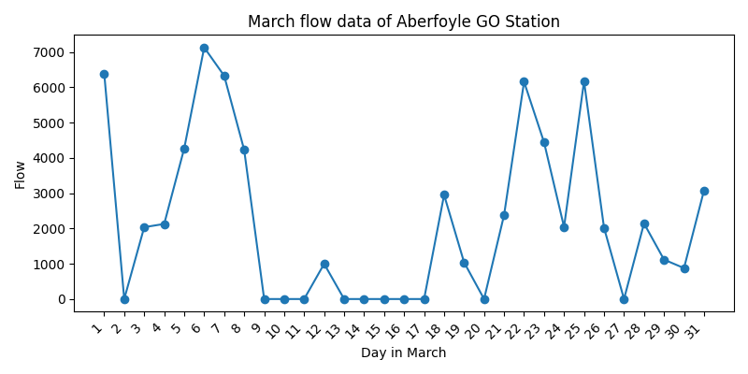

# Appendix C: Site Notes